Intel Corporation
2200 Mission College Blvd.
P.O. Box 58119
Santa Clara, CA 95052-8119
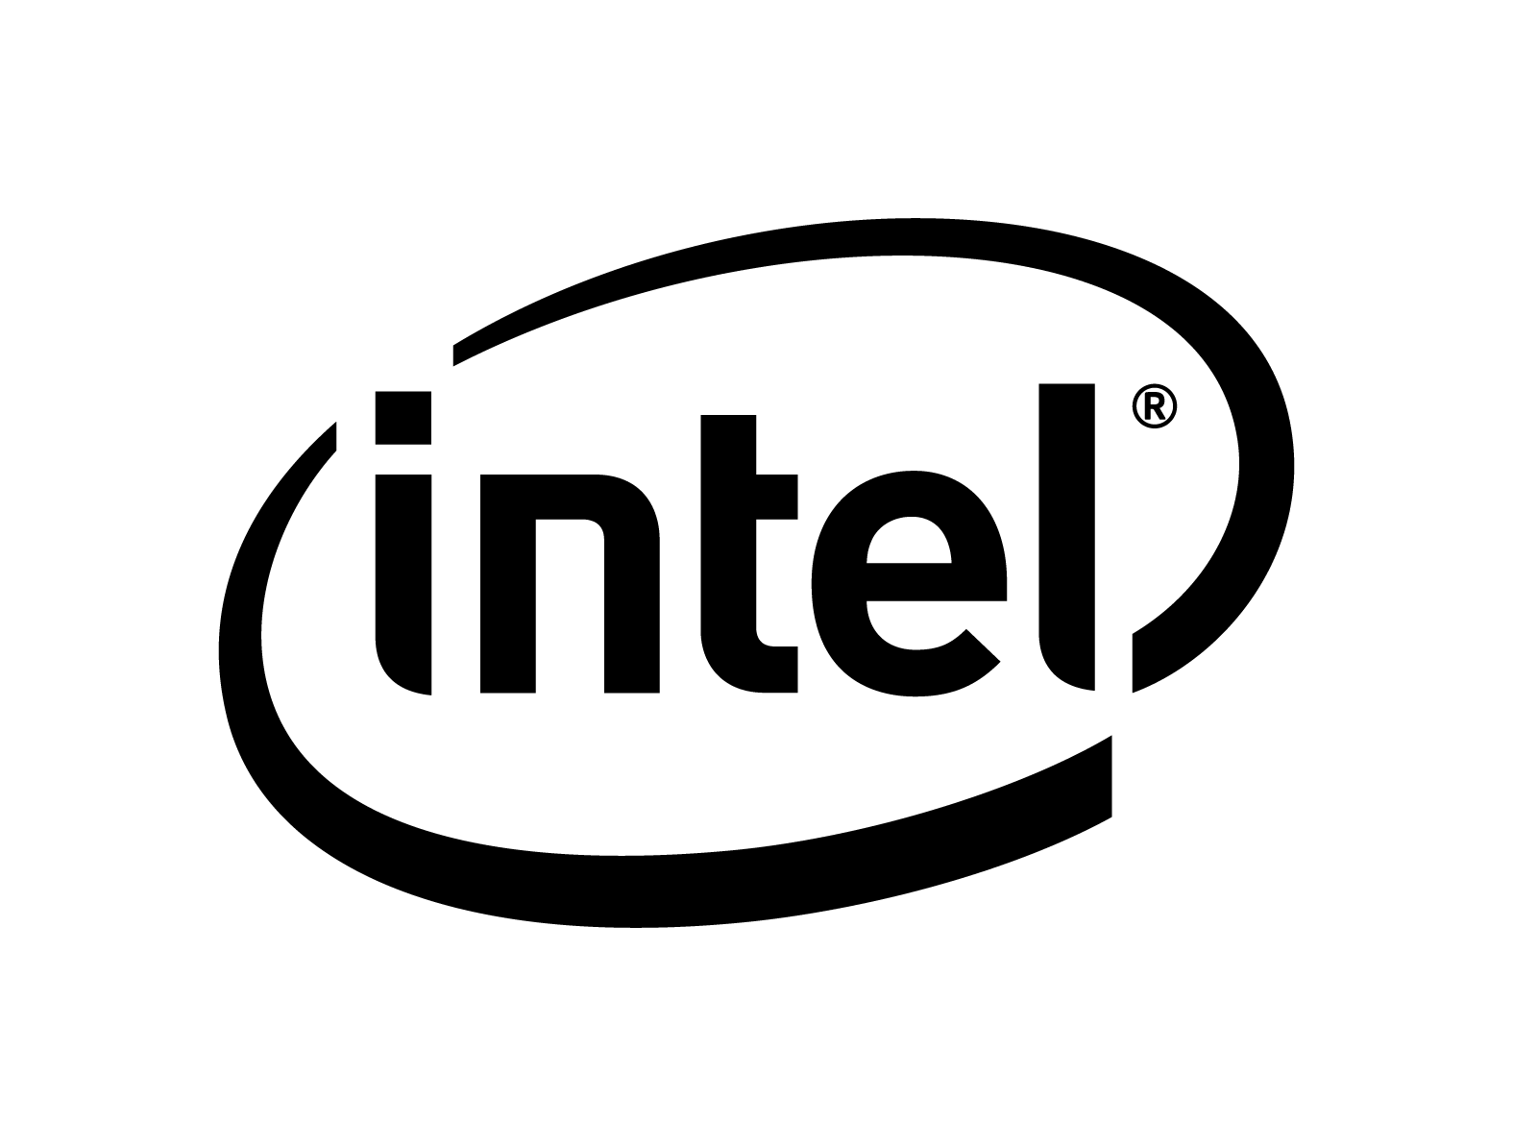 News Fact Sheet
CONTACTS: Claudine Mangano Elvin Ong
408-765-0146 408-765-0651
claudine.a.mangano@intel.com elvin.ong@intel.com

Intel Developer Forum DAY 2 NEWS Disclosures

Aug. 20, 2008: Intel Corporation is holding its Intel Developer Forum in San Francisco from Aug. 19-21. Below are brief summaries of each executive’s keynote speech and news highlights for Day 2.

    
Eric Kim, “I Love TV”
Intel Senior Vice President and General Manager, Digital Home Group
Describing how the TV plays an integral role in people’s lives, reaching more than 1.3 billion households around the world, Eric Kim discussed why the time is right for the Internet to come to the TV. Building on one of Intel’s strategic growth areas, Kim introduced the company’s first purpose-built IA System-on-Chip (SoC) for consumer electronics (CE), the Intel® Media Processor CE 3100 (formerly codenamed “Canmore”), and highlighted the chip’s performance features, Internet and software compatibility, and the robust CE features that Intel has integrated into the chip to achieve this new technology solution. In addition, Intel and Yahoo!* previewed an applications framework for television, called the Widget Channel*, which fuses the Internet and television experiences. Finally, Kim offered insight into the company’s future silicon roadmap with “Sodaville,” Intel’s next-generation IA SoC for CE based on the Intel® Atom™ processor and scheduled for introduction in 2009.

Intel Launches First IA System-on-Chip for Consumer Electronics – Kim introduced the Intel Media Processor CE 3100, the company’s first purpose built IA SoC for CE devices such as optical media players, advanced cable set top boxes, digital TVs and other connected CE devices. Formerly codenamed “Canmore,” the highly integrated SoC pairs a powerful Intel® Pentium® M processor core at 800MHz and 256K L2 Cache, with leading-edge multi-stream high-definition video decoding and processing hardware, including support for MPEG-2, H.264 and VC-1 with HDMI 1.3a output, and featuring advanced 4-field per pixel motion-adaptive de-interlacing and 9-tap, 128-phase, independent horizontal and vertical scalers. It also adds a 3-channel 800 MHz DDR2 memory controller supporting tiled memory mapping and channel interleaving, dedicated multi-channel dual audio DSPs with support for 7.1 surround sound implementing advanced audio codecs, including support for Blu-ray requirements. The media processor also features the powerful 2-D/3-D Intel ® Graphics Media Accelerator 500 supporting multi-threaded dual universal scalable shader architecture for pixel/vertex processing, accelerated BLTs/Alpha BLTs, programmable anti-aliasing and compliance with industry-standard APIs: OpenGL ES 1.1, Open GL ES 2.0 and Open VG 1.0.
-- more --
Intel/Page 2

In addition, the Intel Media Processor CE 3100 features Intel® Media Play Technology. The technology enables the SoC to decode video content from broadcast, stored and broadband sources using a combination of on-chip hardware decoders and software codecs running on the IA processing core. Together, this combination will allow the viewer to easily switch among the media sources. The ability to decode multiple video and audio formats in software will also provide the industry with greater flexibility to evolving standards and technologies. Intel will ship to Intel Media Processor CE 3100 customers starting next month. Additional product details can be found at www.intel.com/go/celink.

Intel Announces Intel® Media Processor CE 3100 Development Platform – Kim announced the Intel Media Processor CE 3100 development platform that is designed to facilitate early software application development, using the provided Software Developers’ Kit, including sample applications. The platform also provides developers the flexibility to evaluate new types of devices and usages. With IA at the heart of the platform, developers can engage with the thousands of registered independent software vendors already developing applications for the majority of IA-based clients.

Intel Demonstrates Reference Designs for Blu-ray, U.S. Cable, Connected CE Devices – Intel is demonstrating Intel Media Processor CE 3100 Reference Designs for Blu-ray and U.S. Cable in the CE Pavilion. During IDF, Intel previewed these reference designs which facilitate quick time to market for OEMs that will be developing products for these segments. The Blu-ray and U.S. Cable reference designs will support the internet experience for connected DVD, cable set top boxes and Blu-ray players including support for BD-Live. The Blu-ray platform combines a small form factor PCB, chassis, Blu-ray drive, and complete Blu-ray software player stack that takes advantage of the new Intel® Media processor CE 3100 to provide a high-performance platform for BD-Java applications. The U.S. Cable Reference Design, which is tru2way™ ready, is a full cable reference stack using the CE 3100 Development Platform. Intel is also demonstrating a connected CE platform that combines DVB-T, PVR, DLNA and additional technologies.

Intel and Yahoo! Collaborate to Bring the Internet to TV via TV Widgets – In related news, Intel and Yahoo! Inc. previewed an applications framework for televisions and related CE devices that use the Intel Architecture, blending the openness, personality and community aspects of the Web with the simplicity and entertainment strengths of the TV. This application framework, called the Widget Channel, introduces a new and user-friendly way to enjoy Web content while watching TV programs. The Widget Channel is powered by the Yahoo! Widget Engine and is optimized to use the performance and the capabilities of Intel Media Processor CE 3100. [A separate press release and more information about the Widget Channel and the Yahoo! Widget Engine are available at www.intel.com/pressroom/idf or connectedtv.yahoo.com/newsroom.]
    

Anand Chandrasekher, “Mobile Internet Devices: The Innovation Platform”
Intel Senior Vice President and General Manager, Ultra Mobility Group
Chandrasekher discussed the increasingly pervasive nature of the Internet and the trends accelerating this growth that include social networking, user-generated content and location-based services. Users also want to carry this full Internet experience with them in their pockets (or purses). He said that the Intel® Atom™ processor Z5xx series-based Mobile Internet Devices (MIDs) are rapidly becoming platforms for innovation in the mobile ecosystem and showcased a number of devices that are beginning to come to market. Additionally, Chandrasekher announced a range of software ecosystem partners embracing the Moblin-based OS to deliver exciting applications and services across MID target market segments. He also reinforced Intel’s MID roadmap with the next-generation platform codenamed “Moorestown,” and announced that first silicon has been produced.
-- more --
Intel/Page 3

Intel® Atom™ Processor-Based Platforms Continue to Get More Compelling – Chandrasekher discussed how Intel’s Atom processor delivers the highest performance in the sub-3W segment while consuming dramatically lower power. Chandrasekher demonstrated Intel’s highest performance Intel Atom processor running at 1.86GHz on an OQO Productivity MID and showcased “World of Warcraft,” one of the most intensive Web sites on the device. He also announced the support of Full HD (1080p, 30fps) in the Intel® System Controller Hub and showed the world’s first demo with this capability in a handheld device.

First-Generation MIDs Come to Market – In his keynote, Chandrasekher welcomed executives from Clarion and Panasonic who announced that their Intel Atom processor-based MIDs are coming soon to the U.S. market. Clarion’s MiND, which stands for Mobile Internet Navigation Device, is targeted as the next-generation navigation device with real-time, location-based services and full Internet-based experiences. Panasonic’s Toughbook CF-U1 is the industry’s first Atom processor-based and ruggedized UMPC, and Panasonic’s Mobile Clinical Assistant (MCA), based on the Intel MCA platform, is designed for health care professionals. Additionally, Chandrasekher showcased the Fujitsu Lifebook* based on the Intel Atom processor and the world’s smallest convertible PC, which is shipping in Asia Pacific and coming to the U.S. and Japan soon. Intel also demonstrated a series of Intel Atom processor-based MIDs at IDF including Aigo*, Asus*, BenQ*, BYD*, Clarion*, Compal*, Digifriends*, Fujitsu*, Gigabyte*, Hanbit*, Kohjinsha*, Lenovo*, Panasonic*, PearTree*, Sharp*, Trigem*, USI*, Wibrain* and Yukyung*.

MID Ecosystem Continues to Gain Momentum – The MID software ecosystem based on Moblin (www.moblin.org) continues to gain momentum with thousands of community developers and hundreds of ISVs actively working to deliver middleware and applications for MIDs. Chandrasekher announced that Neusoft*, a premier software and services company in China, is joining the MID ecosystem and will be working with MID customers to deliver Moblin compliant apps. Additionally, Intel announced a number of new ecosystem players that are joining the MID ecosystem, including California Micro Devices* (MIPI display interface solutions), Fluffy Spider Technologies* (UI innovation), Fuel Games* (branded games), GyPSii* (social networking and location based services), Livecast* (streaming video), McAfee* (mobile security solutions), Move Networks* (Internet Video delivery solutions), Orb Networks (anywhere media access), ThunderSoft* (Software services) and VirtualLogix* (virtualization support).

Intel on Track with Next-Generation “Moorestown” platform – Chandrasekher reinforced Intel’s MID roadmap with the next-generation platform codenamed “Moorestown,” which is on track for 2009/2010. Holding up the first wafer, he announced that first silicon has been produced, reinforced the versatility of the architecture, and the opportunity to target the communication MID with data and voice capabilities.

    

Renee James, “Developing for the Future of Computing”
Intel Vice President and General Manager, Software and Solutions Group

Describing new opportunities created by the digital revolution, Renee James explained how parallel programming on Intel’s multi-core processors will fuel the next leap forward in visual computing by enabling developers to create richer, more believable experiences. Highlighting examples from movie entertainment, PC gaming and medical imaging, she discussed how the power of Intel’s multi-core processors will enable a new generation of 3-D imagery.

-- more --
Intel/Page 4

InTru™ 3D Brand: James and DreamWorks Animation* CEO Jeffrey Katzenberg jointly unveiled InTru™ 3D, a new brand describing the next generation of movie storytelling that features a highly enhanced 3-D viewing experience. The InTru 3D logo, which features computer-generated 3-D imagery made possible by combining Intel’s cutting-edge technology with DreamWorks Animation’s creativity, will be employed by Intel and DreamWorks to promote the studio’s 3-D movies beginning with 2009’s “Monsters vs. Aliens.”

Visual Adrenaline Software Developer Program: In response to the needs of today’s leading 3-D game developers, James introduced Intel’s Visual Adrenaline developer program, specifically tailored to support visual computing software developers. Visual Adrenaline offers resources to help developers, publishers, animators and other gaming and digital content professionals take full advantage of Intel technologies. James highlighted some of these resources, including a new Visual Computing Developer Community, the Intel Visual Adrenaline Magazine, the Intel Software Partner Program and the Intel Software College. More information is available at www.intel.com/software/visualadrenaline.

Parallel Programming Software Tools: James also announced the Intel® Parallel Studio, which includes the Intel® Parallel Advisor, Intel® Parallel Composer, Intel® Parallel Inspector and Intel® Parallel Amplifier, providing solutions for finding, exploiting, debugging and tuning parallelism, respectively. Intel Parallel Studio makes multi-core programming productive for Microsoft Visual Studio developers while helping preserve their investments by providing for forward scaling to future many-core processors. For more information, visit www.intel.com/go/parallel.

Intel® Certified Solutions Program: James discussed broad availability of the Intel® Certified Solutions program. Powered by SpikeSource*, Intel Certified Solutions Program provides software vendors a means to test their software for compatibility, interoperability and security on multiple platform, OS and application configurations, improving the quality and reliability of their software solutions for Intel customers. More information can be found at certification.intel.com.

-- 30 --

Intel and the Intel logo are trademarks of Intel Corporation in the United States and other countries.
* Other names and brands may be claimed as the property of others.

