Intel Corporation
2200 Mission College Blvd.
P.O. Box 58119
Santa Clara, CA 95052-8119
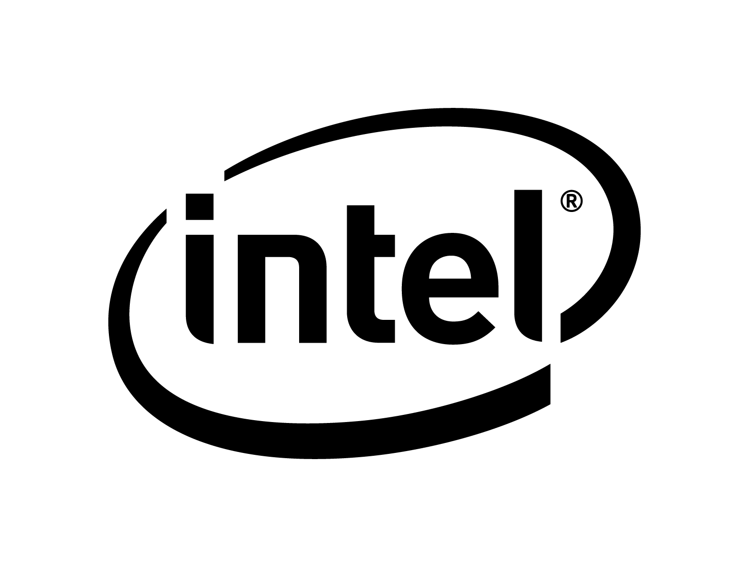 Fact Sheet
CONTACTS: Nick Knupffer George Alfs Elvin Ong
408-250-7265 408-765-5707 408-765-0651
nick.knupffer@intel.com george.alfs@intel.com elvin.ong@intel.com

Intel Developer Forum DAY 1 NEWS Disclosures

Aug. 19, 2008: Intel Corporation is holding its Intel Developer Forum in San Francisco on Aug. 19-21. Below are brief summaries of each executive’s keynote speech and news highlights for Day 1.

    

Patrick Gelsinger, “iA=Embedded+Dynamic+Visual”
Intel senior vice president and general manager, Digital Enterprise Group
Patrick Gelsinger described the opportunities around the shift to a digitally connected Internet environment in the areas of embedded, visual and dynamic computing. Gelsinger disclosed key architectural features of Intel’s next-generation Intel Core Microarchitecture previously codenamed “Nehalem” including the Intel® Core™ i7 processor which will begin production in 4Q.

Nehalem Microarchitecture spanning a range of products – The Intel® Core™ i7 processor and a variant designed for the efficient performance server segments codenamed “Nehalem-EP” will be the first segments of the Nehalem microarchitecture in the market. A derivative designed for the expandable sever market (“Nehalem-EX”) as well as the desktop and mobile versions (“Havendale,” “Lynnfield,” “Auburndale” and “Clarksfield”) will be in production in the second half of 2009.

Nehalem Microarchitecture technical disclosures –
- Turbo Mode – In response to workload demand, adds higher speed to active cores.
- Power Gates – Enabled by Intel in-house design and process technology. Turns individual cores on/off. Transparent to OS. Ultra low leakage. Cores can run at independent voltage/frequency.
- Intel Hyper-Threading Technology – New and improved with more processor resources.
- Over 3X increase in memory bandwidth
- Almost 2X increase in 3-D animation performance
- Intel Core i7 and X58 Chipset – Production Q4, 4 cores – 8 threads with Hyper-Threading, turbo mode, 8MB of Intel Smart Cache, QuickPath, integrated 3 channel DDR 3 memory controller, PCI Express 2.0
- Calpella and Piketon 2009 Platforms – Two chip solution. CPU has integrated memory controller and optional graphics version. IBEX Peak, centralized platform capabilities

Intel Xeon processor update – Gelsinger also announced that the new 6-core Intel Xeon processor for expandable servers will launch in September, and has already broken multiple world performance records** – notably the first x86-based server to burst through the 1 million barrier in the industry- standard TPC Benchmark* C benchmark which measures database performance. An eight-socket IBM System x* 3950 M2 server shattered the previous record with a score of 1,200,632 tpmC at $1.99/tpmC. Other record scores include a HP ProLiant* DL580 G5 server topping the four-socket record for TPC Benchmark* C with a score of 634,825 tpmC at $1.10/tpmC and a Sun* JVM/Solaris best four-socket SPECjbb*2005 score of 531,669 bops. Also, a Dell PowerEdge* R900 server sets the four-socket on-line transaction processing brokerage database record on TPC Benchmark* E with a score of 671.4 tpsE at $500.55/tpsE, Fujitsu-Siemens PRIMERGY* RX600 S4 server running SPECint*_rate2006 benchmark, which measures integer throughput, set a new four-socket record with a score of 277, and a notable improvement in virtualization consolidation environment with VMware ESX* Server, highlighting 39 percent better performance than previous-generation Intel Xeon processor based platforms.

Larrabee update - Gelsinger also discussed the industry’s first many-core x86 architecture, codenamed “Larrabee.” Expected in 2009 or 2010, the first product based on Larrabee will target the personal computer graphics market, support DirectX and OpenGL, and run existing games and programs. Larrabee is expected to kick start an industry-wide effort to create and optimize software for the dozens, hundreds and thousands of cores expected to power future computers. Over time, the consistency of Intel architecture and thus developer freedom afforded by the Larrabee architecture will bring about massive innovation in many areas and market segments. A broad potential range of highly parallel applications including scientific and engineering software will benefit from the Larrabee native C/C++ programming model.

Embedded Internet – Gelsinger outlined Intel’s vision for the next wave of the Internet, called the Embedded Internet. Emerging markets in the embedded computing space such as IP networking and security, video intelligence, medical, in-vehicle infotainment and home automation can greatly benefit from the always-on connectivity that drives the consumer device space. Intel views this embedded Internet device market as an opportunity of greater than $10 billion by 2011 and predicts that an additional 15 billion such devices will connect to the Internet by 2015.

    

Dadi Perlmutter “Where will on-the-go, go?”
Intel Executive vice president and general manager, Mobile Platforms Group
Intel raised the bar to further extend the “on-the-go” computing experience with the first working 2009 mobile platform codenamed “Calpella” at IDF today. Dadi Perlmutter also highlighted the first Intel mobile quad-core processor based workstation and one of many low-voltage, thin and light notebooks. Perlmutter also showed future mobile platform enhancements coming later this year including the Intel® High-Performance SATA Solid-State Drive Product Line and Intel® Anti-theft technology. Together with a robust showcase of laptops, netbooks and MIDs, Perlmutter clearly demonstrated the extensive design possibilities and devices made possible by Intel’s mobile processor technologies.

Mobile Quad Core Processors - Intel’s first mobile quad-core processors, the Intel® Core™2 Extreme QX9300 and the Intel® Core™ 2 Quad Q9100, offer four separate and powerful processing cores to deliver unprecedented multi-threading performance:
- World’s first and highest-performing mobile quad-core processor⁹ – Intel 45nm Hi-K process technology; four cores running at 2.53 GHz with a 1066MHz FSB and 12MB L2 cache.
- Ultimate CPU engine - Incredible performance on highly-threaded applications; great game play and realism on immersive multi-threaded games; headroom for the growing number of multi-core- enabled games and applications; overspeed protection removed to enable system tuning for maximum performance.¹⁰ More information: www.intel.com/products/processor/core2xe/mobile/index.htm.
- Intel’s best quad core mobile processor technology - The Intel Core 2 Quad Q9100 is a new CPU for the Intel® Centrino® 2 processor technology and Intel® Centrino® 2 with vPro™ technology lineup. Offering quad-core performance for intensive, demanding HD multimedia and workstation applications and industry-leading battery life for quad-core processing, the mobile quad-core processor is based on Intel’s 45nm Hi-K process technology running at 2.26 GHz, with a 1066MHz FSB and 12MB L2 cache.

Small Form Factor Processors -- Eight new small form factor processors, including two Power Optimized Performance, two new low-voltage, and two new ultra low-voltage Intel® Core™2 Duo processors, as well as a new Intel® Core™2 Solo processor and a new Intel® Celeron processor.
- Lower TDP – Intel’s new small form factor processors have lower TDPs than typical 35W mobile mainstream products and come in smaller package sizes (22x22mm vs. 35x35mm).

More information on SKUs and pricing can be found at:
- www.intel.com/products/processor/core2duo/index.htm
- www.intel.com/products/processor/celeron_m/index.htm
- www.intc.com/priceList.cfm (after 9PM PST on August 19)

New mobile Intel GS45 Express chipset – New small form factor Intel chipset for Intel Centrino 2 processor technology and Intel Centrino 2 with vPro technology. Optimized for power and performance with similar capabilities and performance to the Mobile Intel® GM45 Express chipset for an outstanding mobile computing experience. See www.intel.com/Products/Notebook/Chipsets/GS45/GS45-overview.htm
- Smaller chipset footprint – Measuring only 25x27 and 16x16mm compared to a standard 34x34mm and 31x31mm for a standard Mobile Intel® GM45 Express chipset means PC manufacturers can now design cooler, thinner and lighter Intel® Centrino® 2 processor technology-based notebooks together with the PCIe* half mini card Intel® WiFi Link 5000 series.

Intel® High Performance SATA Solid State Drives – Intel® High-Performance SATA Solid-State Drives for use in notebook, desktop and server/storage applications, are drop-in compatible to existing SATA HDDs. Available in either a 1.8-inch or 2.5-inch standard hard drive form factor, the Intel® X18-M and X25-M Mainstream Solid-State Drive (SSD) will bring a new level of performance and reliability to laptop and desktop PC storage that will translate into lighter, more durable notebooks with longer battery life and quicker performance. Saving up to 30 minutes in battery life, this line of SSDs based on multi-level cell flash memory, is validated on Intel platforms and helps minimize the input/out (I/O) bottleneck to the CPU to deliver noticeably faster system performance. For the PC gamer and enthusiast, these drives deliver compelling performance to enhance your overall computing experience.

Intel® Anti-Theft Technology (PC Protection) – Coming later this year is the optional Intel® Anti-Theft Technology (Intel® AT) for Intel Centrino 2 with vPro technology-based laptops. Intel AT offers the option of activating via a security ISV or service provider, a hardware-based client-side intelligence to disable the PC and/or access to encrypted data if the notebook is lost or stolen. Intel AT also includes two rapid reactivation mechanisms for “theft mode”: a local passphrase pre-provisioned by the user or a one-time-use recovery token generated by IT or the service provider upon request by the user. Available later this year from select OEMs, including Lenovo and Fujitsu Siemens Computers. Service providers which support Intel AT include Absolute Software Corporation and Phoenix Technologies Ltd. Additional OEMs and security ISVs are planning to offer solutions in 2009.

– 30 –

** 1, 2, 3, 4, 5, 6, 7, 8, 9, 10 - For additional information, disclaimers and system configurations see: http://download.intel.com/pressroom/kits/events/idffall_2008/IDF_Day1_FactSheet.pdf

*Other names and brands may be claimed as the property of their respective owners. SPEC, SPECint, SPECfp, SPECrate, SPECweb, SPECjbb are trademarks of the Standard Performance Evaluation Corporation. See: http://www.spec.org for more information on the benchmarks.

Copyright © Intel Corporation 2008

