Opel ADAM: pregled tehničkih podataka

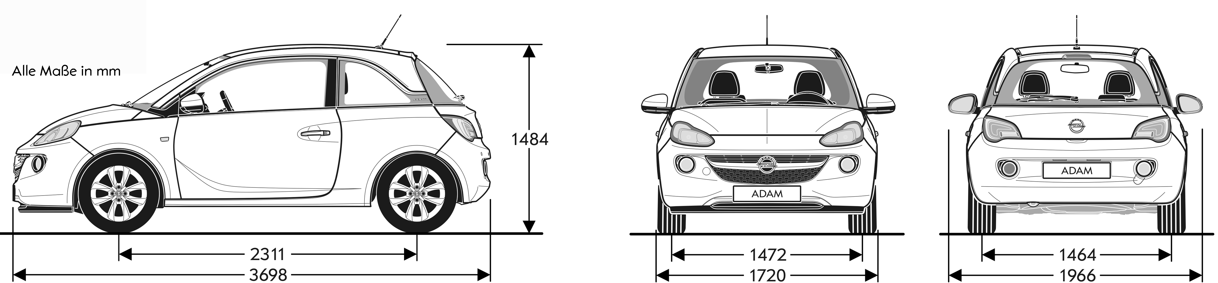
Engines | 1.2 / 1.2 ecoFLEX | 1.4 / 1.4 ecoFLEX | 1.4 / 1.4 ecoFLEX
Emission classification | EURO5 | EURO5 | EURO5
Fuel | Super | Super | Super
Number of cylinders | 4 | 4 | 4
Displacement cm³ | 1229 | 1398 | 1398
Bore / stroke in mm | 73,4 / 72,6 | 73,4 / 82,6 | 73,4 / 82,6
Max. output in kW (hp) / at rpm | 51 (70) / 5600 | 64 (87) / 6000 | 74 (100) / 6000
Max. torque in Nm / at rpm | 115 / 4000 | 130 / 4000 | 130 / 4000
Compression | 10,5 : 1 | 10,5 : 1 | 10,5 : 1
Final drive ratio | 3,74 | 3,94 | 3,94
Fuel tank capacity in l | 38 | 38 | 38
Weight and axle loads in kg
Curb weight incl. driver (according to 70/156/EEC) | 1086 | 1120 | 1120
Permissible gross vehicle weight | 1455 | 1465 | 1465
Payload | 369 | 345 | 345
Permissible axle load, front | 805 | 805 | 805
Permissible axle load, rear | 680 | 690 | 690
Permissible roof load ¹⁾ | 50 | 50 | 50

5-speed manual | Maximum speed  in km/h | Acceleration  from 0 – 100 km/h in s | Elasticity 80-120 km/h in 5th gear in seconds | Fuel consumption (l/100 km) |  |  | CO2 emissions in g/km (combined) | Efficiency rating
 |  |  |  | Urban | Extra-urban | Combined | CO2 emissions in g/km (combined) | Efficiency rating
1.2 (51 kW) | 165 | 14,9 | 26,8 | 7,1 | 4,2 | 5,3 | 124 | D
1.2 ecoFLEX (51 kW) with Start/Stop | 165 | 14,9 | 26,8 | 6,5 | 4,2 | 5,0 | 118 | C
1.4 (64 kW) | 176 | 12,5 | 17,8 | 7,3 | 4,4 | 5,5 | 129 | D
1.4 ecoFLEX (64 kW) with Start/Stop | 176 | 12,5 | 17,8 | 6,6 | 4,2 | 5,1 | 119 | C
1.4 (74 kW) | 185 | 11,5 | 17,8 | 7,3 | 4,4 | 5,5 | 129 | D
1.4 ecoFLEX (74 kW) with Start/Stop | 185 | 11,5 | 17,8 | 6,6 | 4,2 | 5,1 | 119 | C
All data are subject to alteration and refer to the European base model with standard equipment. Fuel consumption data and CO2 emissions data are determined according to regulation 2007/715/EC, taking into consideration the vehicle curb weight, as stipulated by the regulation. Additional equipment can lead to slightly higher fuel consumption and therefore CO2 exhaust emissions than the declared values. In addition, they can raise the vehicle’s curb weight and in some cases also increase the gross vehicle weight, the maximum allowable axle loads and respectively reduce the permitted trailer load. Therefore the maximum speed may be decreased while acceleration time can be increased. The published performance figures are possible with the vehicle’s curb weight excluding driver plus a 200 kilogram load allowance.

Dimensions and Weights
Vehicle dimensions in mm
Length | 3698
Width including / excluding door mirrors | 1966 / 1720
Height (at curb weight) | 1484
Wheelbase | 2311
Track, front | 1472
Track, rear | 1464
Turning circle in m
Wall-to-wall | 10,17 - 11,06
Curb-to-curb | 9,80 - 10,74
Luggage compartment dimensions in mm
Floor length to rear seat backs | 462
Floor length with rear seat backs folded forward | 1041
Width measured at wheel housing | 954
Max. width | 963
Height of sill | 808
Max. aperture height | 544
Max. aperture width measured at waistline | 853
Luggage compartment in liters (according to ECIE)
Luggage compartment only | 170
With rear seat backs folded forward up to front seat backs | 484
With rear seat backs folded forward up to ceiling | 663
Reduction of luggage compartment with
- Infinity Sound System | 75

All data are subject to alteration and refer to the European base model with standard equipment. In some trim levels, the curb weight and in some cases the permissible axle loads can increase the permissible gross vehicle weight or reduce the payload.

¹⁾ Under consideration of gross vehicle weight. For safety reasons it is recommended not to drive over 120 km/h with a roof load.

