

Dr Malcolm William Kennedy, CBE, FREng, FRSE - Non-Executive Director, Narec

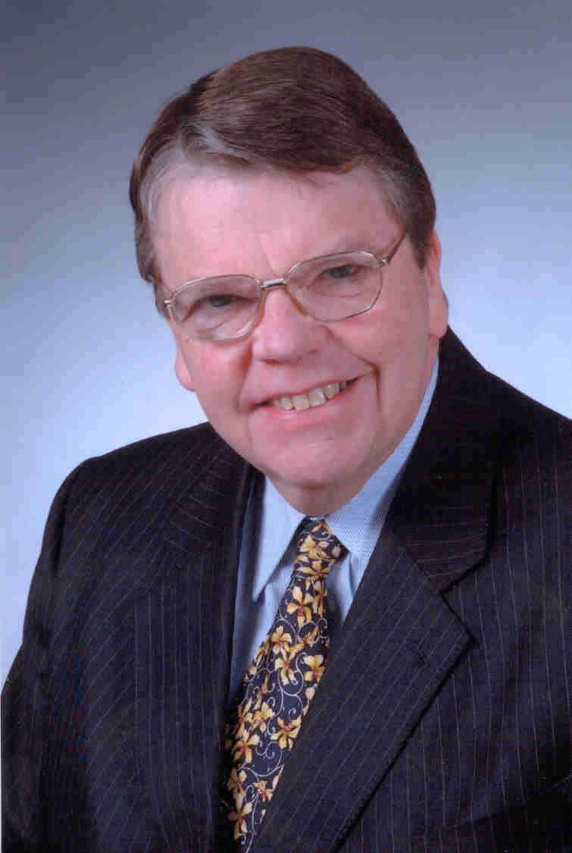
Dr Malcolm Kennedy was born on Tyneside and after being apprenticed to CA Parsons & Co. Ltd during the 1950s he took a degree in Electrical Engineering at King’s College in the University of Durham followed by a PhD from the University of Newcastle upon Tyne.

Dr Kennedy joined Merz and McLellan, the Newcastle-based consulting engineering firm where he specialised in electricity supply system design, construction and performance from Low Voltage up to 500kV and High Voltage Direct Current systems before being invited into Partnership in 1981.

In 1987 he led the Merz team advising the Department of Energy and the Scottish Office on technical aspects of the Privatisation of Electricity in the UK and currently advises the Office of Electricity Regulation (OFFER), moving on to become Senior Partner and subsequently their first Chairman and Managing Director. With the merger of Merz and McLellan and American consultants Parsons Brinckerhoff Inc., Dr Kennedy became Executive Chairman of Merz and McLellan Limited and, in 1999, Chairman of PB Power Ltd which includes the power businesses of Merz and McLellan and Kennedy & Donkin.

He has been President of the Institution of Electrical Engineers (IEE) and became a Fellow of the Royal Academy of Engineering in 1985. He was elected a Companion of the British Institute of Management in 1992 and in 2002 he was elected a Fellow of the Royal Society of Edinburgh.

He has been a Member of the Electricity Panel of the Monopolies and Mergers Commission (MMC) and also a Member of the Water and Telecommunications Panels of the Competition Commission (formerly MMC).

In 2002 he was appointed a Member of the DTI/Ofgem Distributed Generation Coordination Group, set up to consider how to incorporate renewable generation into the electricity system.

Appointed Non-Executive Director of Narec in 2004, of Renewable Energy Generation in 2007 and Business Advisor to Applied Superconductor Ltd in 2009.

At the end of 1999, he was awarded a CBE in recognition of his services to exports to developing countries.

